North American Society for Trenchless Technology (NASTT)
2023 No-Dig Show
Portland, Oregon
April 30 – May 4, 2023
MM-T2-01
Is HDD an Inherently Dangerous Activity? Ruling by Judge in HDD Crossing Parallel to Lift Bridge Has Significant Potential Implications for Industry
Dave Bennett, PhD, PE, Bennett Trenchless Engineers, Folsom, California
Andrew Showen, Board Certified Construction Lawyer, HRKM Law, Orlando, Florida
- Abstract
In a recent construction claim involving an HDD waterway crossing in Florida, the judge granted the defense counsel’s summary motion for summary judgment against the claim against the HDD Contractor. In the judge’s decision, he concluded that the event was unforeseeable. The claim centered on inoperability of a lift bridge section during an HDD crossing which was parallel and approximately 90 feet from the bridge. The plaintiff, through its expert, claimed that drilling fluid escaped through karstic features in the limestone during HDD operations and lifted an overlying marine clay layer in which the bridge lift section piers were founded.
The judge cited testimony from all the experts that they had never observed or heard of a case where drilling fluid escaped the bore and traveled almost 100 feet, collected beneath a bridge foundation, and built-up sufficient pressure to heave the overlying clay layer and bridge piers, all while circulation was maintained. However, (and this however is the main impetus for this paper), the judge also included a statement outside the legal decision that even though the event was unforeseeable, the HDD industry should be put on notice that should such an event occur again, that a judge could reasonably conclude the subsequent event was foreseeable.
This statement by the judge, though not a part of the official ruling, implies that the judge apparently accepted the plaintiff’s argument that drilling fluid escaped the bore and heaved the clay layer on which the lift section piers were founded. This argument appears tenuous at best, and it is surprising and dismaying that the judge seemed to accept it. The pilot bore had been completed and drilling fluid could, and did, exit the bore at either entry or exit. Circulation was never lost. Drilling fluid usage was reasonable. The bridge lift section became inoperable during reaming when the reamer was over 200 feet from the lift section. So why would drilling fluid escape the bore and travel over 200 feet through potentially discontinuous, tortuous karstic features which had not been documented during the geotechnical investigation, stop exactly beneath the lift section foundation, and lift the clay layer, instead of continuing to flow out of the bore or continuing to flow through the karstic features?
This paper examines the probability of the plaintiff’s theory and defense rebuttal, and the implications of the judge’s statement for the HDD industry.
- Introduction
A Florida circuit court has rejected a claim by a property owner that HDD is an abnormally dangerous activity, and held that the HDD contractor could not be subjected to strict liability for alleged damage to a bridge 90 feet from the bore path. In an earlier ruling, the court held that the alleged damage to a bridge 90 feet away from the bore path was legally unforeseeable and the HDD contractor was not liable under a simple negligence theory.
On September 22, 2020, Judge Edward Nicholas in Manatee County granted a summary judgment in favor of the HDD contractor, T.B. Landmark Construction Co., after 4 ½ years of litigation. However, the judge expressed concerns at the final hearing that, while this 2014 incident had not been foreseeable at the time, going forward, the court would view this incident as a notice to the HDD industry that damage to remote structures could be considered legally foreseeable.
- PRoject Background
The case arose out of a directional bore for a 16” water main under Longboat Pass, commissioned by the owner, the Town of Longboat Key, in Manatee County, Florida. The bore was to commence from the north side of Longboat Pass, at Manatee Beach, and proceed approximately 2,100 feet north-south under the seabed through the pass, emerging on Longboat Key. Figure 1 is a picture of the bridge showing the lift span and operator control cabin. Figure 2 is an aerial view of the bridge with the HDD bore alignment shown. The bore path ran approximately 90 feet east of and roughly parallel to the Longboat Pass bridge, approximately 74 feet below the surface. The two-lane drawbridge bridge was built in the 1950s. The bore path also ran under a curved seawall (left of photo).
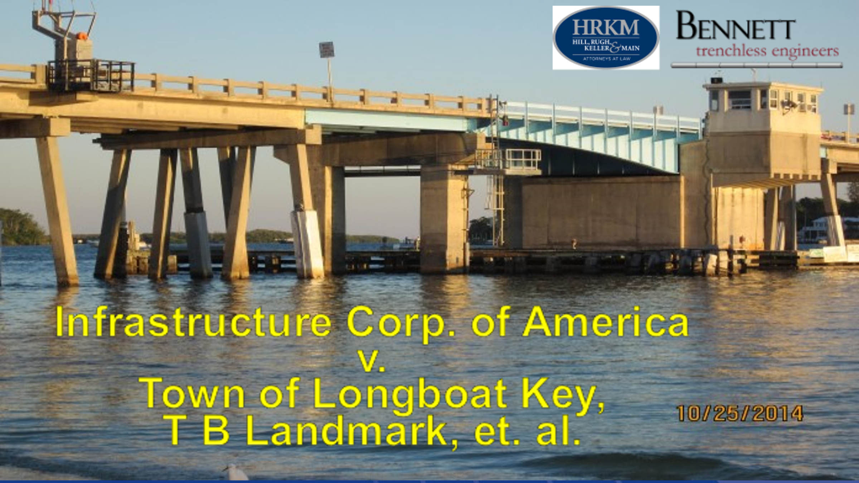
Figure 1. Photograph of Longboat Key lift bridge showing lift span and operator cabin.
Figure 2. Aerial view of bridge with HDD bore alignment shown. (image from project engineer’s file).
By October 24, 2014, T.B. Landmark had completed the pilot bore without incident, and was pulling the reamer head back toward the rig to the north from the south end of the bore.
  - The Incident - The Drawbridge Locks Jam
Between 7 and 8 a.m. on October 24th, 2014, Landmark was pulling the reamer back. Around the same time, the drawbridge operator was carrying out the first few bridge openings of the day. The drawbridge leaf opened once without incident, but then could not be lowered all the way down into the rest pier. The large pin that locked the leaf horizontally into the rest pier became jammed in the receiver and could not be removed by operating the bridge motor. Figure 3 illustrates the inoperable span in the partially raised position.
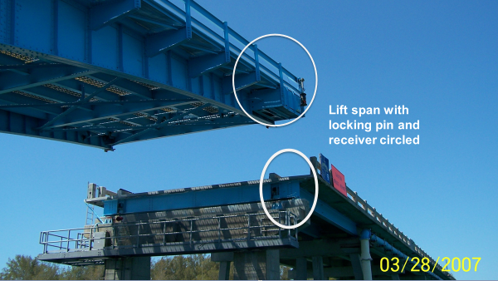
Figure 3. Photograph of partially raised lift span with locking pin and receiver circled, to illustrate the incident.
Florida Department of Transportation engineers and the bridge maintenance company concluded that the bridge had moved and authorized an emergency repair to install a new crutch bent on piles driven to 105 feet. When FDOT’s geotechnical engineer conducted SPT bores in the seabed near the bridge during the design phase for this new crutch bent, approximately three weeks after the incident, it reported a gray material at a depth of approximately 56 feet below sea level, issuing from the borehole under pressure.
Figure 4 shows the bridge and locations of SPT borings. The consultant opined that the material was drilling fluid from the HDD bore. At that time, the HDD operation had been completed and demobilized for a week. Some of the bridge operator’s engineers theorized that drilling fluid had escaped from the HDD bore, under pressure, traveled through karstic limestone fissures, and heaved the rest pier onto which the leaf would lower.

Figure 4. Longboat Key Bridge showing locations of forensic borings.
  - The Claim - Negligence and Strict Liability
Based on the geotechnical consultant’s opinion, FDOT’s management contractor, ICA, sued T.B. Landmark, the Town of Longboat Key, the general contractor and the project design engineer and OAR in 2016, alleging that the construction and engineering team had been negligent in conducting the HDD bore. Another count of the complaint alleged all of the construction team were strictly liable to ICA, because HDD was an “abnormally dangerous activity,” and should be treated by the law like using dynamite or pile driving.
ICA’s expert witnesses theorized that drilling fluid had gradually escaped into the limestone, travelled through a channel or fissures under pressure, then traveled up through the limestone until it reached an impervious clay bed under the bridge’s rest pier. They contended pressurized fluid would have travelled up through the pervious limestone, then met the clay layer, and the pressurized fluid would have created a “bubble”, lifting the clay layer above it. The rest pier was embedded in the clay layer, and it was theorized the heaving clay layer lifted the rest pier out of position, causing the lock pin to misalign with the receiver and become stuck on the morning of the incident.
- Evaluation of the Claim
When the claim was received, the HDD subcontractor T.B. Landmark and its legal team consulted with engineers and professionals. No one had ever heard of an HDD bore causing a structure of the mass of a bridge to heave, 90 feet away from the bore.
T.B. Landmark denied that there had been any negligence or any anomalies in what was a successful bore. The rig operator testified there had been no significant loss of drilling fluid, as one might expect would be necessary to create a “bubble” under the clay layer large enough to heave a bridge pier. Drill pressures were normal and there had been no incidents of pressure spikes.
The material that came up under pressure during the SPT boring was captured in a bottle by the FDOT’s geotechnical consultant and sent to a lab, but was never tested. The lawyers litigated for access to test the sample, only to discover than the geotechnical consultant had thrown out the sample without it being tested. Witnesses on the scene and experts disagreed in depositions whether the material was bentonite slurry, or liquefied clay native to the seabed with a “marine odor” and carried up under artesian pressure. Thus, there was never conclusive testing one way or the other whether the gray liquid material was escaped drilling fluid or native clay, liquified.
  - The Foreseeability Defense
The legal team presented the further legal defense that, because there was no history of this type of event ever happening, it was unforeseeable as a matter of law and the court should dismiss the case. Under the law of Florida and most common law jurisdictions, a person who causes a remote or freak accident which the court finds not to be foreseeable in human experience may be excused from liability if the court finds the injury was not the kind of outcome that could have reasonably been foreseen.
The defense relied on the following line of cases, which are enlightening on the fact that the law does not impose liability for unpredictable events:
“The policy of the law will of course not allow tort liability to attach to all conduct factually “caused” by a defendant:

Florida courts, in accord with courts throughout the country, have for good reason been most reluctant to attach tort liability for results which, although caused-in-fact by the defendant's negligent act or ommission, [sic] seem to the judicial mind highly unusual, extraordinary, bizarre, or, stated differently, seem beyond the scope of any fair assessment of the danger created by the defendant's negligence. Plainly, the courts here have found no proximate cause in such cases based solely on fairness and policy considerations, rather than actual causation grounds. Stahl v. Metropolitan Dade County, 438 So.2d at 19.”
Dep't of Transp. v. Anglin, 502 So. 2d 896, 899 (Fla. 1987).
The challenge for defendants, however, is whether a jury of six people will agree what is foreseeable and what is not. Under most states’ law, the judge, not the jury, gets the first crack at determining foreseeability.
“This requirement of reasonable, general foresight is the core of the duty element. For these same reasons, duty exists as a matter of law and is not a factual question for the jury to decide.”(e.s.)
McCain v. Florida Power Corp., 593 So. 2d 500, 503 (Fla. 1992).
However, summary judgments are difficult to obtain.
  - Risk To The Industry Presented by the Strict Liability Claim
The strict liability claim presented particular risk to the HDD industry. Strict liability means the defendant can be held liable for damages it causes, even if it is operating with reasonable or the utmost care. If strict liability is applied, the HDD operator would essentially become an insurer for all damages that anyone could plausibly claim were caused by the HDD work. This ruling would have significantly increased legal risk and cost to the HDD industry and its customers.
Only one court had previously decided whether HDD was abnormally dangerous. In Tri-County Metro v Time Warner Telecommunications, 2008 WL 4572519 (D. Ore. 2008), the Federal district court in Oregon had rejected the transit district’s claim that the HDD team should be held strictly liable for HDD placement of fiber optic lines under its rail lines during an extensive project. The defense team considered resting its defense on this one case. However the defense attorney decide the risk was too high to bet the entire case on one trial court opinion from Oregon.
The defense lawyer researched what seemed to be the most authoritative source on whether HDD was inherently dangerous, or could be done safely, and found the NASTT HDD Good Practices Guidelines. This manual is an industry-accepted standard for HDD good practices, and a landmark USACE research study. T.B. Landmark and its insurer, Zurich, retained one of the authors, Dr. Bennett, as HDD expert witness. Later Dr. Bennett’s role was expanded to develop opinion that it was unlikely that drilling fluid would travel at least 90 feet from the bore path through undetected fissures and voids in the limestone, collect beneath the marine clay layer supporting the lift span foundation, and retain sufficient pressure to lift the clay layer and damage the lift span.
Large-scale field research conducted by the US Army Corps of Engineers Waterways Experiment Station in the 90s had indicated that drilling fluid pressures decayed rapidly with distance from the HDD bore (Staheli and Bennett, et. al., 1998). T.B. Landmark’s expert presented testimony, by affidavit and deposition, that it was highly improbable that drilling fluid under pressure could have traveled the distance to the bridge and retained the pressure necessary to lift the clay layer carrying the bridge section, estimated to weigh 600 tons. TB Landmark’s expert cited evidence including inspector’s daily reports and the driller’s logs to corroborate that drilling fluid circulation had been maintained and that no significant drilling fluid losses had occurred. He noted that the incident occurred during the reaming process, when both ends of the HDD bore were open. Key questions included, “Why would drilling fluid travel over 90 feet through tortuous pathways through irregular fissures and voids and collect under the marine clay layer, building sufficient pressure to lift the clay layer and foundation piers supported by the clay layer? Why wouldn’t the drilling fluid just flow out through the open HDD bore?” TB Landmark’s expert also cited the thousands of successful HDD crossings in a variety of geological conditions all over the world to negate the argument that HDD was an abnormally dangerous activity.
Dr. Bennett also gave opinion testimony on the so-called “six part test” for strict liability under the Restatement(Second) of Torts Sec. 519 and 520, which are:
- Whether the activity involves a high degree of risk of some harm to the person, land or chattels of others;
(b) Whether the harm which may result from it is likely to be great;
(c) Whether the risk cannot be eliminated by the exercise of reasonable care;
(d) Whether the activity is not a matter of common usage;
(e) Whether the activity is inappropriate to the place where it is carried on; and
(f) The value of the activity to the community.'"
This testimony is significant because his opinion that HDD is not abnormally dangerous, giving consideration to all six of these issues, is in the judicial record.
During the four years of the litigation, T.B. Landmark’s defense team questioned 13 engineers and bridge maintenance specialists. All testified they had never heard of a structure of the mass of a bridge having been heaved by pressurized drilling fluid escaping from an HDD bore, and none would testify that HDD met any of the six legal criteria under the Restatement (Second) of Torts Sec. 519 that could lead the courts to impose strict liability because an activity is abnormally dangerous.
One issue in contention was that the mere existence of the HDD subcontractor’s standard safety plan, with an action plan for prevention of and response to fluid losses (“frac-outs”) demonstrated foreseeability of the type of damage claimed. Ultimately, the court did not accept this argument.
Another issue litigated was the fact that the project engineer had called for movement monitoring of the seawall that ran roughly diagonally about 135 degrees to the centerline of the bridge. The plaintiff argued this too was evidence that it was foreseeable that the bridge, 90 feet away, could be impacted. The construction and design team defendants argued that the fact that the plan called for monitoring the seawall directly above the bore path, but not the bridge, demonstrated that a) care was taken for foreseeable damage to nearby structures, but b) no one on the design team believed the bridge was at risk.
  - Possible Alternate Causes For The Incident
T.B. Landmark’s structural engineering expert, Sean Burlingham, P.E., had noted that, on the morning of the incident, there had been a significant temperature change for Florida. In addition, there had been a flood tide that morning, creating unusual tidal pressure on the rest pier. The temperature swing and the flood tide fortuitously coincided, and impacted an older bridge reported by FDOT to be experiencing scour problems at the rest pier in question. The structural expert waited for another cool season day which would coincide with a spring tide, and spent 4 days continuously monitoring temperatures and the movement of the bridge. He opined that the bridge lock up was the result of an unusual confluence of thermal expansion and contraction on a chilly October morning, which warmed up rapidly, at the same time as a full moon flood tide, which acted together to temporarily throw the leaf’s lock pins out of alignment with the receivers in the rest pier. He also cited FDOT and maintenance inspection records showing failure to maintain the bridge’s moveable bearings, which should have better accommodated thermal expansion.
- Summary Judgment On Lack of Foreseability
In December 2019, the court granted T.B. Landmark’s motion for summary judgment, finding that because there was no evidence of a structure of this mass having ever been heaved by an HDD bore at this distance, the event was unforeseeable as a matter of law. No one could reasonably foresee drilling fluid travelling the required distance under pressure through limestone. The court also noted the evidence that there had been no evidence of loss of fluid, purchases of large or unaccounted quantities of bentonite, or other red flags during the bore. The court followed the holding of the Florida Second District Court of Appeal in City of Sarasota v Eppard, 455 So.2d 623 (Fla. 2d DCA 1984), explaining that a defendant cannot be held liable for “highly unusual, extraordinary or bizarre consequences resulting from an alleged breach of duty. It dismissed the negligence count against T.B. Landmark. However, the strict liability claim remained.
The judge’s ruling from the bench, however, should give the HDD industry some concern. The judge observed that:
19 Going forward, is there reasonable
20 foreseeability of damage of this nature?
21 Probably so, now that we have the hindsight of
22 the events that took place on October 24th of
23 2017.(sic)

This comment was not part of the final order, or the record in the case, and arguably a throwaway observation at the end of a hard fought 7 year-long case.
- Resolution of The Strict Liability Claim
Strict liability is a legal doctrine that imposes a duty to pay for losses on a party, even when the party has exercised reasonable care. Strict liability is different from simple negligence, where the injured party must show that the defendant breached some standard of care, or acted unreasonably. The courts impose strict liability in specialized and limited situations, most commonly, activities that are known to be inherently dangerous, such as the use of dynamite for blasting, fumigating for termites, or pile driving. The courts theorize that when activities are predictably dangerous and can cause damage even when great care is exercised, the courts will transfer the cost of the activity to third parties back to the entity creating the risk, as a cost of doing business. In theory, the cost is then passed back to the customer, or the insurer.
The ICA lawsuit against T.B. Landmark had the potential to move HDD into one of those classes of construction activity for which there is strict liability. This would have had significant cost impact on the industry, and owners and insurers.
In July 2020, the court heard final arguments on the abnormally dangerous claim. Judge Nicholas gave credence to TB Landmark’s expert’s affidavit and deposition testimony that HDD was not abnormally dangerous so as to justify strict liability. The court agreed that the HDD operation did not satisfy the six-part test for imposition of strict liability.
ICA appealed the summary judgments, but the appeal was voluntarily dismissed.
T.B. Landmark was represented by Andrew Showen, a board-certified construction lawyer who was a Zurich staff attorney and is now with Hill Rugh Keller & Main P.L. in Orlando, Florida.
- Lessons From The Case
Important lessons from this case for HDD operators and those in the industry include:
  - Create and Keep Great, Not Just Good Records
The HDD contractor’s boring logs included date, time and pressure readings at the beginning and end of every drill pipe. Those records enabled the defense to argue that there was no evidence of a pressure spike.
As with most projects, some records were misplaced. Regrettably, the current legal trend is to argue the loss of documents into evidence is a sign of wrongdoing and a coverup. Retaining the records created is important. A handwritten note, written on the job at the time and place of the event, is as powerful as a formal report typed up in an office; maybe more so.
Among the issues litigated in this case was whether the HDD contractor purchased unusually high quantities of bentonite under invoices saying “RUSH”. Plaintiff’s expert suggested this was evidence of unexpected fluid loss, consistent with a frac-out under the seabed and a release of fluid into the limestone. There was extensive calculation and argument about the required quantity of bentonite to do the job without incident, and whether the purchase of more bentonite than expected under a “RUSH” order was evidence of a problem. It’s doubtful anyone expected the bentonite orders and delivery tickets would become important evidence in a $2.4 million claim – but it happened.
  - Create and Keep Cell Phone and Other Pictures
Cell phone pictures of original pressure measurements in the cab of the rig – in some cases of the gauges themselves – became important to corroborate the validity of the drilling log summaries, the accuracy of which were challenged. Images of the work area provided context to explain the project, and hem in speculative testimony. Informal photos of the bridge on the date of the incident taken by the engineers who responded – who took pictures on their own initiative before even being engaged as experts – helped explain the nature of the problem.
  - Text Messages and Emails Are Future Trial Exhibits
We are a decade into the era of texting for work, and three decades into email. Nevertheless, emails and work texts still blur into personal texts, and contain informalities, gossip, intemperate language, speculation among friends, or worse. Several emails from the plaintiffs’ team following the incident suggested the bridge moved because of tidal conditions, or because it was just an old bridge. It’s important for field personnel to understand that text messages they send on personal phones to run a project are project records. They need to be preserved. They need to be written with care, with the expectation that someday a jury may read them and decide a case on what they see.
  - Downhole Sensors
At the time of this project, downhole sensors were not industry standard. However, data concerning location, fluid pressure and other information could have quickly extinguished this claim.
  - The Industry Needs More Research Into Fluid Escape Into Different Ground Conditions
The defense position for the HDD contractor was based on years of experience, but also, the Staheli and Bennett research for the US Army Corps of Engineers showing that drilling fluid pressures drop dramatically in a short distance after escape from the bore into sand The plaintiff’s expert challenged the relevance of that study of fluid travel into sandy soils, to the situation at Longboat Pass, where the bore passed through karstic limestone shot through with unpredictable channels and crevices, and capped with impervious clay.
The defense was fortunate that every testifying witness, on both sides of the case, acknowledged they had never heard of a similar incident. However, the law tends to limit the ability of experts to testify based on experience, and requires peer reviewed studies consistent with the expert’s opinion, before allowing a jury to hear the opinion. Defense counsel was concerned that a challenge could have been presented to TB Lamdmark’s expert testimony based on the different soil conditions in the USACE (Staheli and Bennett, 1998) study. A similar study conducted in karstic limestone, a common Florida geological condition, could have been helpful in this case.
While the question of whether HDD is an abnormally dangerous activity was rejected by the judge on this case, the question could cast a chill over the industry. The question of foreseeability of pressurized drilling fluid from an HDD operation lifting a bridge 90 feet away is quite troubling.

